**Change the belling_the_cat to newdata14:**

Iter= 10000, Average Loss= 2.565005, Average Accuracy= 45.80%

['settled', 'in', 'our'] - [first] vs [first]

Optimization Finished!

Elapsed time: 1.9334867914517722 min

Run on command line.

3 words: from all I

from all I comforts heard, we chief for the reality, but were chief master’s in efficiently, days has in comforts gentlemen society New the those gentlemen society New the those gentlemen society New the those

**Question1 and 2, Tensorboard of graph, accuracy and loss:**

Graph:

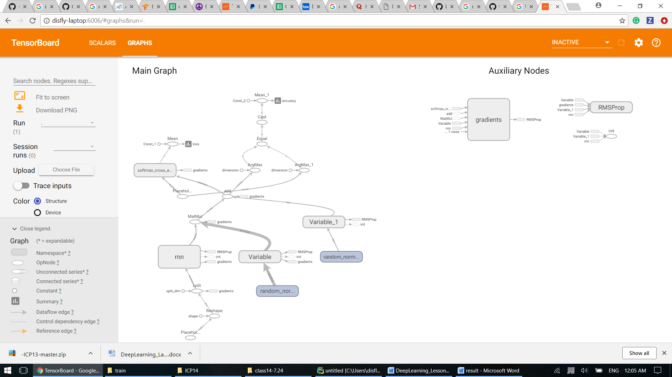

Accuracy and loss:

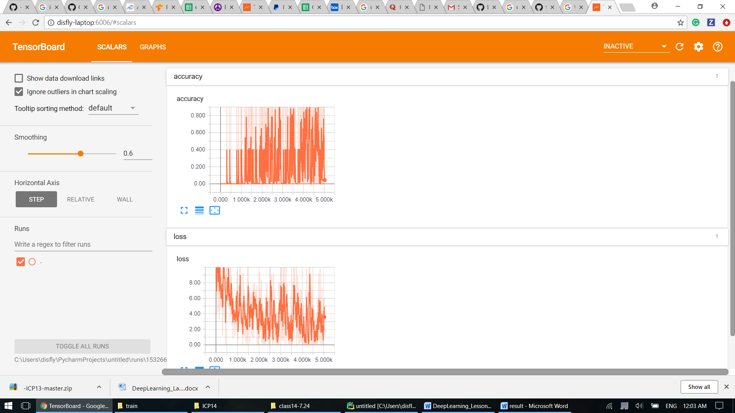

**Question3**: Change the hyper parameters and report the result:

**Learning rate from 0.001 to 0.005: accuracy decreases from 45% to 39%, loss increases from 2.56 to 3.4**

Iter= 10000, Average Loss= 3.471379, Average Accuracy= 39.10%

['established', 'at', 'this'] - [time.] vs [the]

Optimization Finished!

Elapsed time: 2.104838156700134 min

Run on command line.

3 words: the colony were

the colony were few time. in master years of our colonial in England, years that time.

**Optimizer from RMSPropOptimizer to GradientDescentOptimizer:** **accuracy decreases from 45% to 9.9%, loss increases from 2.56 to 3.8**

Iter= 10000, Average Loss= 3.865600, Average Accuracy= 9.90%

['note', 'had', 'been'] - [established] vs [from]

Optimization Finished!

Elapsed time: 1.6937127351760863 min

Run on command line.

3 words: few days in

few days in comforts for few established in latter for few established in latter for few established in latter for few established in latter for few established in latter for few established in latter for

**Question4:** Change the 'n_input' and 'n_hidden' parameter to see the printed version changes (Accuracy, Loss)

**“n_input” from 3 to 5: accuracy decreases from 45% to 15%, loss increases from 2.56 to 3.6**

Iter= 10000, Average Loss= 3.666537, Average Accuracy= 15.00%

['of', 'life.', 'The', 'schools', 'in'] - [the] vs [society]

Optimization Finished!

Elapsed time: 2.5486328125 min

Run on command line.

5 words: a master from note at

a master from note at some I composed in Sydney, first days days I composed in Sydney,

**“n_hidden” from 512 to 256: accuracy decreases from 45% to 11%, loss increases from 2.56 to 4.4**

Iter= 10000, Average Loss= 4.449423, Average Accuracy= 11.00%

['been', 'made,', 'and'] - [a] vs [the]

Optimization Finished!

Elapsed time: 28.25754189491272 sec

Run on command line.

5 words: since I left

since I left in the school, an

**Question5**: Change the code from one stack LSTM to two stack LSTM then observe the result (Accuracy, Loss)

**accuracy decreases from 45% to 10.5%, loss increases from 2.56 to 3.62**

rnn_cell = rnn.MultiRNNCell([rnn.BasicLSTMCell(n_hidden),rnn.BasicLSTMCell(n_hidden)])

*# rnn_cell = rnn.BasicLSTMCell(n_hidden)*

Iter= 10000, Average Loss= 3.625971, Average Accuracy= 10.50%

['our', 'first', 'Australian'] - [home,] vs [in]

Optimization Finished!

Elapsed time: 5.2063505013783775 min

Run on command line.

3 words: reason for stating

reason for stating in the second master of cultured and life. The master time.